Bible Prophecy Symbols
Why cloak Bible prophecies in symbols?
One reason God cloaked the prophecies in symbols was to protect the messages because the prophets were in or captives of hostile foreign lands. God defines each symbol in His Scripture.
In this tract, the symbol is defined. The associated Scripture references will lead to exactly where God has provided the definition.
Be a Berean, test this study guide and learn the Truth of Prophecy. Pray for discernment before reading the Bible in this new light.
Animals and their Parts
Bear = Destructive Power / Medo Persia
Proverbs 28:15, 2Kings 2:23-24, Daniel 7:5

Beast = Kingdom / government/political power
Daniel 7:17, 23

• Dove = Holy Spirit Mark 1:10
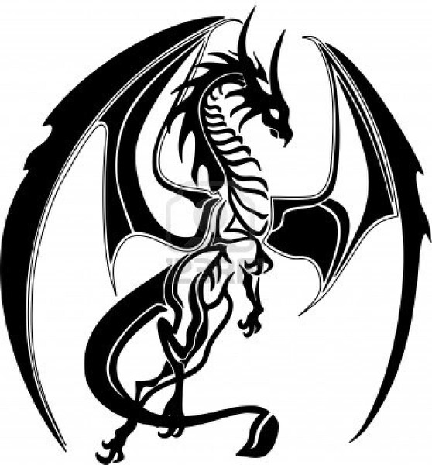
• Dragon = Satan or his agency
Isaiah 27:1; 30:6, Psalms 74:13-14,
Revelation 12:7-9, Ezekiel 29:3,
Jeremiah 51:34

• Goat = Greece Daniel 8:21
• Horn = King or kingdom Daniel 7:24; 8:5, 21-
22, Zechariah 1:18-19, Revelation 17:12
• Horse = Strength and Power in Battle Job 39:19,
Psalms 147:10, Proverbs 21:31

• Lamb = Jesus / sacrifice John 1:29, 1Corinthians 5:7

• Leopard = Greece Daniel 7:6
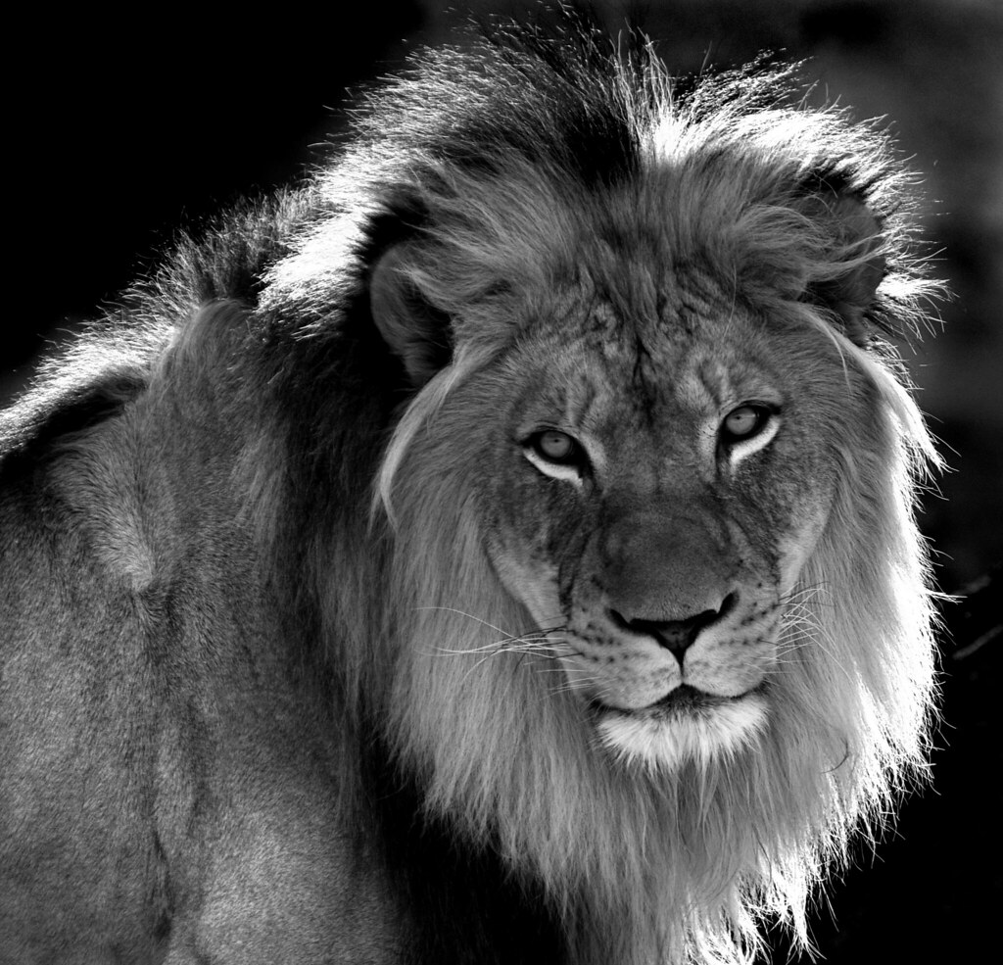
• Lion = Jesus / Powerful King
i.e. Babylon Revelation 5:4-9,
Jeremiah 50:43-44, Daniel 7:4, 17, 23

• Ram = Medo Persia Daniel 8:20

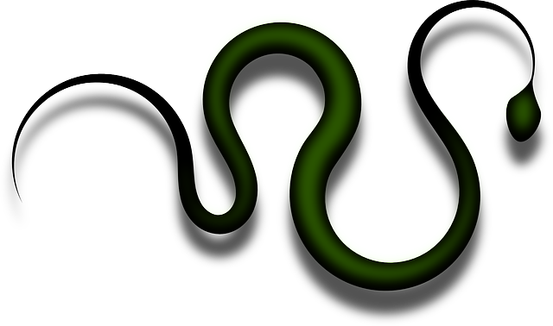
• Serpent = Satan
Revelation 12:9; 20:2; 3:10-11
• Tongue = Language / Speech Exodus 4:10
• Wings = Speed / Protection / Deliverance
Deuteronomy 28:49, Matthew 23:37
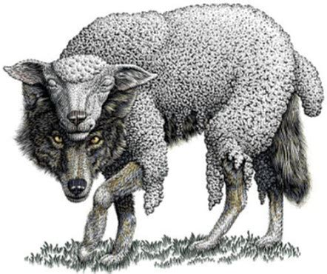
• Wolf = Disguised Enemies
Matthew 7:15

Colors
• Blue = Law Numbers 15:38-39
• Purple = Royalty Mark 15:17, Judges 8:26
• Red/Scarlet = Sin/corruption
Isaiah 1:18, Nahum 2:3, Revelation 17:1-4
• White = Purity Revelation 3:4-5; 7:14; 19:14

Metals, Elements, and Natural Objects
• Brass, Tin, Iron, Lead, Silver dross = Impure
Character Ezekiel 22:20-21

• Fig Tree = A Nation that should bear fruit
Luke 13:6-9

• Field = World Matthew 13:38, John 4:35
• Fire = Holy Spirit Luke 3:16

• Fruit = Works / Actions Galatians 5:22
• Gold = Pure Character Precious and Rare
Isaiah 13:12

• Harvest = End of World Matthew 13:39

• Jordan = death Romans 6:4, Deuteronomy 4:22

• Mountains = Political or religio-political powers
Isaiah 2:2-3, Jeremiah 17:3; 31:23; 51:24-25,
Ezekiel 17:22-23, Daniel 2:35, 44-45

• Reapers = Angels Matthew 13:39

• Rock = Jesus / truth 1Corinthians 10:4,
Isaiah 8:13-4, Romans 9:33, Matthew 7:24

• Seed = Descendents / Jesus Romans 9:8,
Galatians 3:16
• Silver = Pure Words & Understanding
Proverbs 2:4; 3:13-14; 10:20; 25:11,
Psalms 12:6
• Stars=Angels/messengers = Revelation 1:16, 20;
12:4, 7-9, Job 38:7

• Sun = Jesus / the gospel Psalms 84:11, Malachi 4:2,
Matthew 17:2, John 8:12; 9:5

• Thorns / Thorny Ground = Cares of this life
Mark 4:18-19
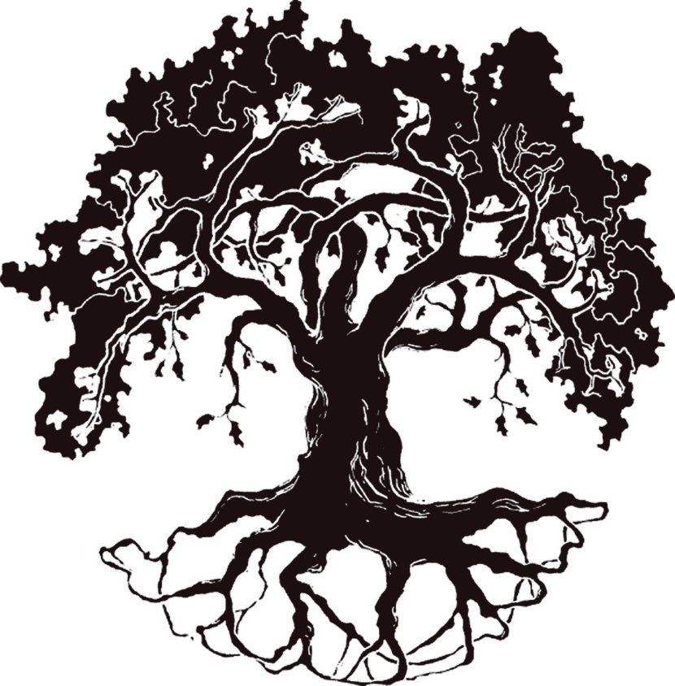
• Tree = Cross; People / Nation
Deuteronomy 21:22-23,
Psalms 92:12; 37:35

• Vineyard = Church that should bear fruit
Luke 20:9-16

• Water = Holy Spirit / Everlasting Life John 7:39; 4:14, Revelation 22:17, Ephesians 5:26
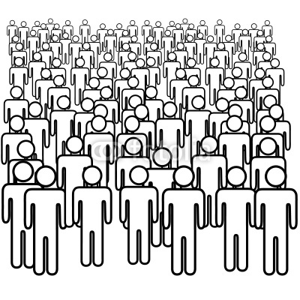
• Waters = Inhabited area/people,
nations Revelation 17:15
• Winds=Strife/commotion/ "winds of war"
Jeremiah 25:31-33, 49:36-37; 4:11-13,
Zechariah 7:14
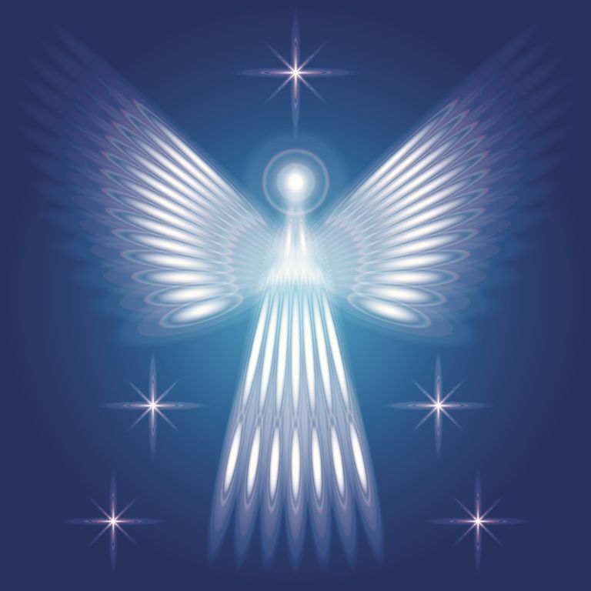
Miscellaneous Objects• Angel = Messenger Daniel 8:16; 9:21,
Luke 1:19, 26, Hebrews 1:14
• Babylon = apostasy / confusion / rebellion
Genesis 10:8-10; 11:6-9, Revelation 18:2-3; 17:1-5

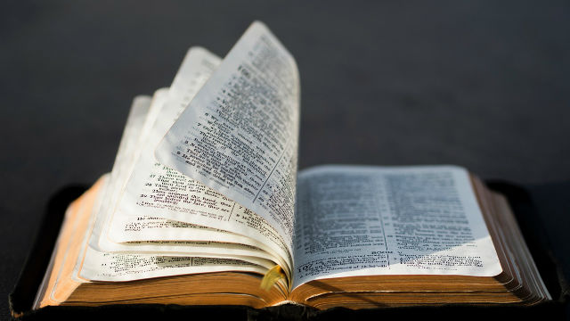
• Bread = Word of God
John 6:35, 51-52, 63

• Clothing = Character
Isaiah 64:6, Isaiah 59:6
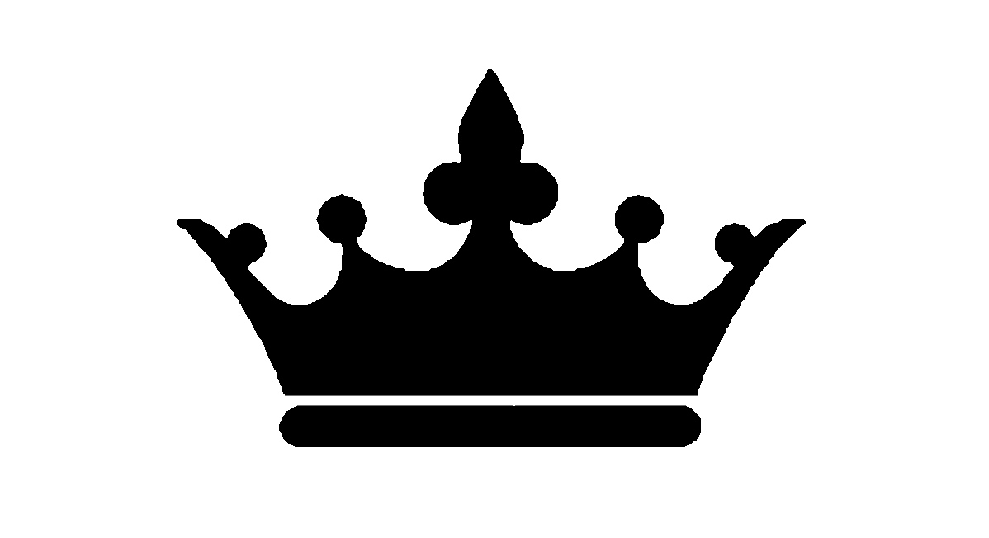
• Crown = A Glorious Ruler or Rulership
Proverbs 16:31, Isaiah 28:5, Isaiah 62:3

• Day = Literal year Ezekiel 4:6, Numbers 14:34

• Honey = happy life Ezekiel 20:6, Deuteronomy 8:8-9

• Jar / Vessel=Person Jeremiah 18:1-4, 2Corinthians 4:7
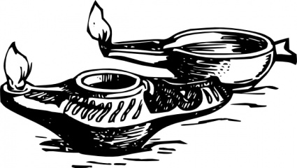
• Lamp = Word of God
Psalms 119:105

• Mark = Sign or seal of approval or disapproval
Ezekiel 9:4, Romans 4:11,
Revelation 13:17; 14:9-11; 7:2-3
• Oil = Holy Spirit Zechariah 4:2-6, Revelation 4:5

• Ring = Authority Genesis 41:42-43, Esther 3:10-11

• Seal = Sign or mark of approval or disapproval
Romans 4:11, Revelation 7:2-3

• Sword = Word of God Ephesians 6:17, Hebrews 4:12

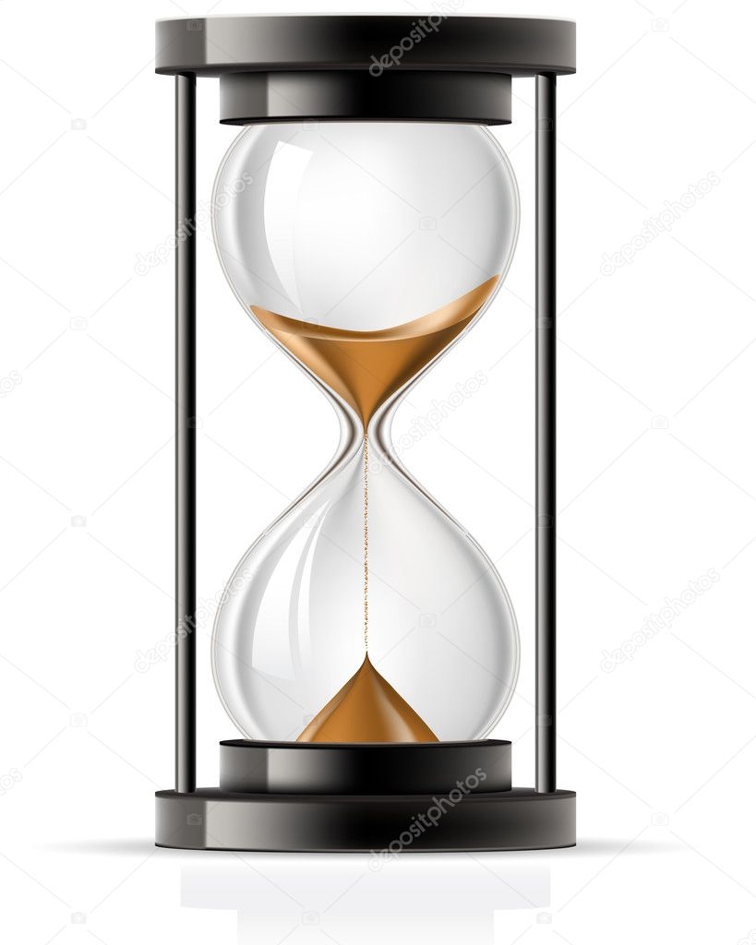
• Time = 360 Day Daniel 4:16, 23,
25, 32; 7:25; Daniel 11:13 margin
• Times = 720 Days Daniel 7:25,
Revelation 12:6, 14; 13:5

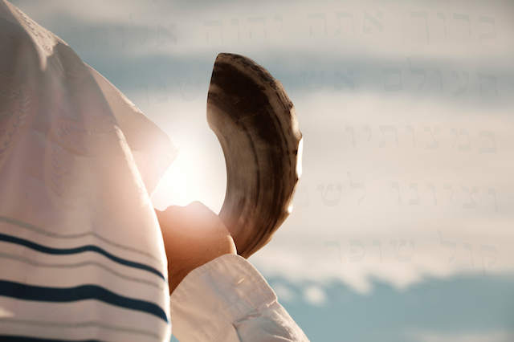
• Trumpet = loud warning of
God's approach
Exodus 19:16-17,
Joshua 6:4-5

• White Robes=Victory / righteousness
Revelation 19:8; 3:5; 7:14

• Wine=blood/covenant/doctrines Luke 5:37

Actions, Activities, and Physical States

• Famine = Death of Truth Amos 8:11
• Healing = Salvation Luke 5:23-24
• Leprosy/Sickness = Sin Luke 5:23-24
People and Body Parts
• Eyes = Spiritual Discernment
Matthew 13:10-17, 1John 2:11

• Feet = Your Walk / Direction
Genesis 19:2, Psalms 119:105

• Forehead = Mind Deuteronomy 6:6-8,
Romans 7:25, Ezekiel 3:8-9

• Hand = Deeds / Works / Actions
Ecclesiastes 9:10, Isaiah 59:6
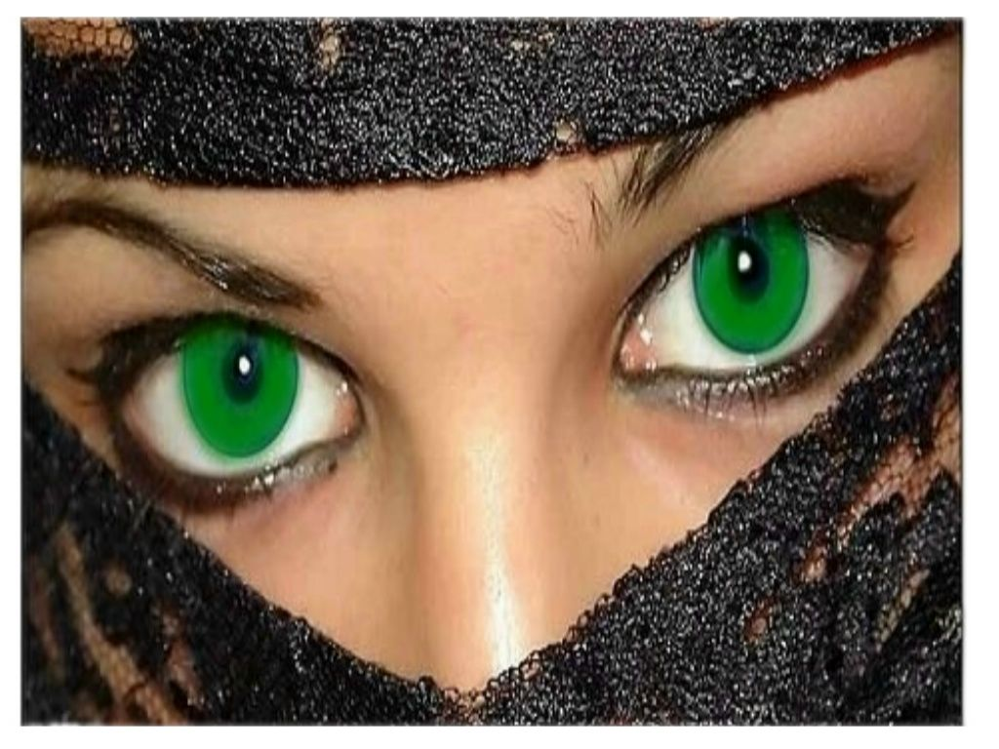
• Harlot =Apostate church or
religion Isaiah 1:21-27,
Jeremiah 3:1-3; 6-9
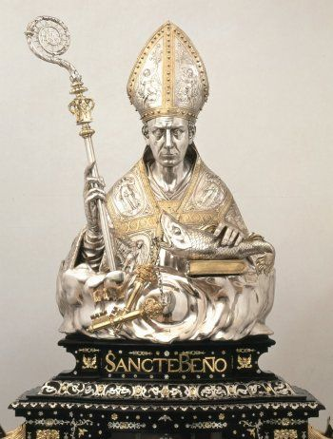
• Heads = Major powers, rulers,
or governments
Revelation 17:3, 9-10

• Skin = Christ's righteousness
Exodus 12:5, 1Peter 1:19, Isaiah 1:4-6

• Thief = Suddenness of Jesus' coming
1Thessalonians 5:2-4, 2Peter 3:10

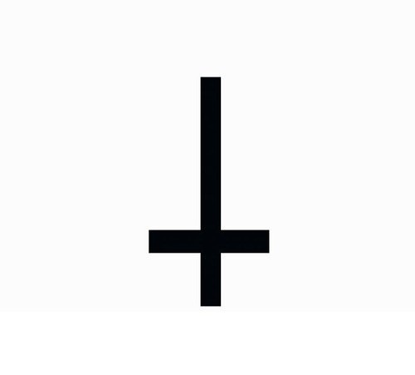
• Woman, Corrupt = Apostate church
Ezekiel 16:15-58; 23:2-21,
Hosea 2:5; 3:1, Revelation 14:4
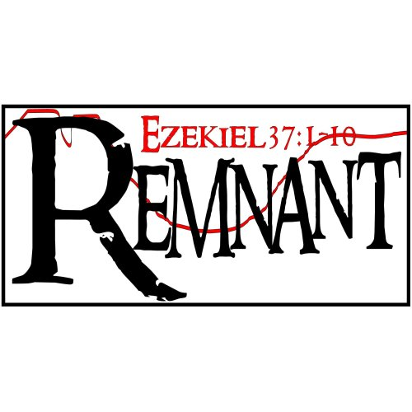
• Woman, Pure = True Church
Jeremiah 6:2, 2Corinthians 11:2,
Ephesians 5:23-27
---------------------------o-O-o------------------------------

Jesus said, "To you it has been given to know the mysteries of the kingdom of God, but to the rest it is given in parables, that Seeing they may not see, And hearing they may not understand." Luke 8:10.
The Bible interprets itself; there is no need for confusion and frustration. Through Bible study, the Word of God will come to life as you bear witness to events happening today that were revealed by His prophets millennia ago.
According to the Word, Christians are told not to give our own opinion of what a prophetic symbol means. We must allow the Word of God to define it’s own symbols. Our private interpretations and opinions are useless. Truth is, there are 404 verses in the book of Revelation; of those 404 verses, 278 of them carry the bulk of the prophetic message of that book? Did you also know that all 278 of those verses can be found almost word for word in all the other books of the Bible? In other words,
THE BIBLE DEFINES ITSELF PERFECTLY! Don’t let anyone give you their “opinion” or “interpretation.” God wants YOU to understand!!
Let the Word define the Word! That’s an easy way to expose false teachers. Just hear what they say, and then open a Bible and see if what they say matches up with what the Lord says regarding a certain symbol. Example:
Revelation 12:17, “And the dragon was wroth with the woman, and went to make war with the remnant of her seed, which keep the commandments of God, and have the testimony of Jesus Christ.”• Dragon = Satan; Woman = Church (See Jeremiah 6:2); seed = descendants; keeping the commandments = self- explanatory; testimony of Jesus Christ = prophecy (See Revelation 19:10) . Now read as, “Satan was angry with the true church and wanted war with her descendants who keep all of God’s Commandments and the prophecies revealed by Jesus Christ. Makes a lot more sense to the reader once Biblical wisdom is applied.
The end time church of Jesus will preach and teach prophecy. DOES YOUR CHURCH DO THAT?
This is because of all the gods and worldly doctrines men have worshiped throughout the ages, our Creator God is the ONLY God who could define, script, and reveal, to those who have the desire for understanding, the beginning to the end of man’s destiny and what to expect on our journey to His Kingdom.
For a more comprehensive listing of prophecy symbols visit:
http://www.remnantofgod.org/books/docs/REV/Revelation.htm


