Easter in Ukraine

Additional research

One of the most famous illustrations of the influence of occultism in historical Orthodoxy is the relic of the phallic cult - "Easter cake", introduced by Byzantine emperors instead of biblical unleavened bread.

Man, created in the image of God, in miniature embodied all the qualities of the Lord-kindness, truth, love, care, the power of creation, domination. And his universe is his Earth. Man, created in the likeness of God, embodied the ability to multiply and multiply his kind, but with one majestic difference in this from the beasts - to give birth in his image, but to bring up posterity in the image of God.

The gift of intimate relationships - the sexual life of a person, has become that area in whose perversion Satan has specialized for thousands of years. This is his favorite subject. What he himself could not be like the Creator, that he decided to abuse in an incredibly perverted form. Maniacal attraction to pervert the sexual relations of the human race makes him the first and main sexual maniac of the Earth of all ages ("You will not have them with Your Word, but I will have them").

The devil understood that in order to defeat Christianity, it was not necessary to destroy it and persecute its followers. It is only necessary to pervert it - this will be the brightest mockery of God and the right path to perish for man. Gradually, having introduced into the pure Christian teaching pagan rites and symbols, but calling them in other words, Satan rejoiced triumphantly.

According to tradition, the roots of which go to India, the arrival of spring was celebrated on March 25. It is known that by this day the Tengrians baked cakes. Cake personified the man's beginning. In India and in many other countries, its symbol was the phallus. Tengrian cake was given the appropriate form, next it was put two colored eggs. There is already a connection with the phallistic agricultural cults of India, but the connection of this custom with the Easter traditions of Christianity is just as obvious. Only the Tengrian customs are more ancient than Christian ones. – *Note: please see attached images of the phallic cakes they bake in the Ukraine, and they also put two eggs with each cake. The baking form is filled with the dough up to the certain point so then when it grows during baking, it comes above the form and expands a little thus closely resembling the form of the male organ. I asked why they had to be of that shape when I was a child and I was told that it was supposed to be that way and it was a tradition, and nobody knew why. Also, please see the similarity with the domes of the Orthodox churches, just like you stated in the Christmas article in section ‘Comparison of Catholicism to Paganism (red table, item #31). It explains everything to me now...*

It is worth to look more closely at the history of the ancient cult of the goddess-mother, associated with the phallic symbolism of the coming of spring.

One of the legends was the well-known story of the death and resurrection of Osiris. The supreme deity of Egypt, the brilliant Osiris, had the beautiful wife Isis and the evil brother Seth. Seth killed Osiris, cut the body of his brother into forty parts and scattered them around the world.

True Isis, having bypassed the whole world, collected all the scattered parts of her beloved husband's body in order to bury him with honor. She could not find only one, but very significant part - the phallus, without which the husband could not in a full sense be considered a husband. Lamenting the deceased spouse and her bitter destiny, Isis sat on the seashore, not daring to bury Osiris in such an understaffed state. At that moment a small fish, known to the current ichthyologists as Chromis, or Cholis (Chromis multicolor), swam up to her and told the inconsolable goddess that she knew where the missing part of her husband was. The problem was only that this part rested deeply on the sea bottom, and the fish could not bring her to Isis, since her mouth was too small.

Then Isis did so that the fish's mouth could grow to any size. The fish dived to the bottom of the sea and brought Isis the last, missing part of the body of Osiris. After Isis joined this part with the entire body of Osiris, he (Osiris, of course) came to life, after that he killed an evil brother and began to rule the world.

With this myth, the Egyptians linked the change of seasons and interpreted the coming of spring as the resurrection of Osiris from death. In honor of this event, the ancient Egyptians held annual festivals. Congratulating each other on the holiday, they proclaimed: "Osiris is risen!" – *Note: in Russia and Ukraine, people greet each other with “Jesus is risen” and now I also understand why during the Easter, many people in the Ukraine have to have the fish on the table... What a cunning craftiness of Satan, who picked up the creature that does not have hands, but mouth only to pick up things...*

*Please see all the pictures below*

[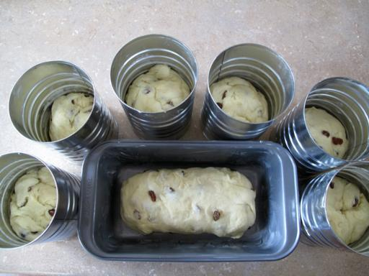](https://www.thekitchenmagpie.com/wp-content/uploads/images/2010/03/11_512x3841.jpg)

[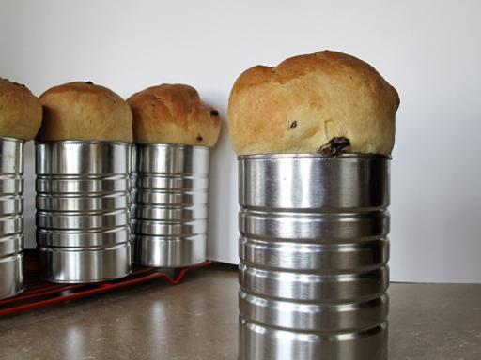](https://www.thekitchenmagpie.com/wp-content/uploads/images/2010/03/easterbread_512x384.jpg)

[](https://www.bing.com/images/search?q=pictures+of+ukrainian+easter+babka&id=BAA21E5DF9F20DCACB36BC2A33C11A6CC816216C&FORM=IQFRBA) This is the end result, the tops only have to be coated in icing which resembles the discharge during sex. These cakes truly look like the phallic additions with domes on the roof of Orthodox churches.

This is a picture of a Saint Basil cathedral in Moscow –

[](https://www.bing.com/images/search?q=saint+basil%27s+cathedral+moscow&FORM=IARRTH&ufn=saint+basil%27s+cathedral&stid=76b0998f-06db-d1ed-a03b-b6f7b7d22832&cbn=EntityAnswer&cbi=0&FORM=IARRTH)